**Created By :**

Lakhani Dinky A. IT062

Modi Aastha N. IT079

Gurvinder Singh P. IT084

**Under the guidance of :**

Prof. Archana N Vyas

Prof Fatema Vhora

**Sem :** 5

**Batch :** H3

**Topic :** OmniLib

**Subject :** Database Management System

**Univ. :** Dharmsinh Desai University

**Joins and Subqueries**

**Inner join**

**Users who haven’t paid through UPI**

**1)select "User_id/email_id","User".payment_id,upi from**

**"User" join payment on "User".payment_id = payment.payment_id**

**where payment.upi = '-';**

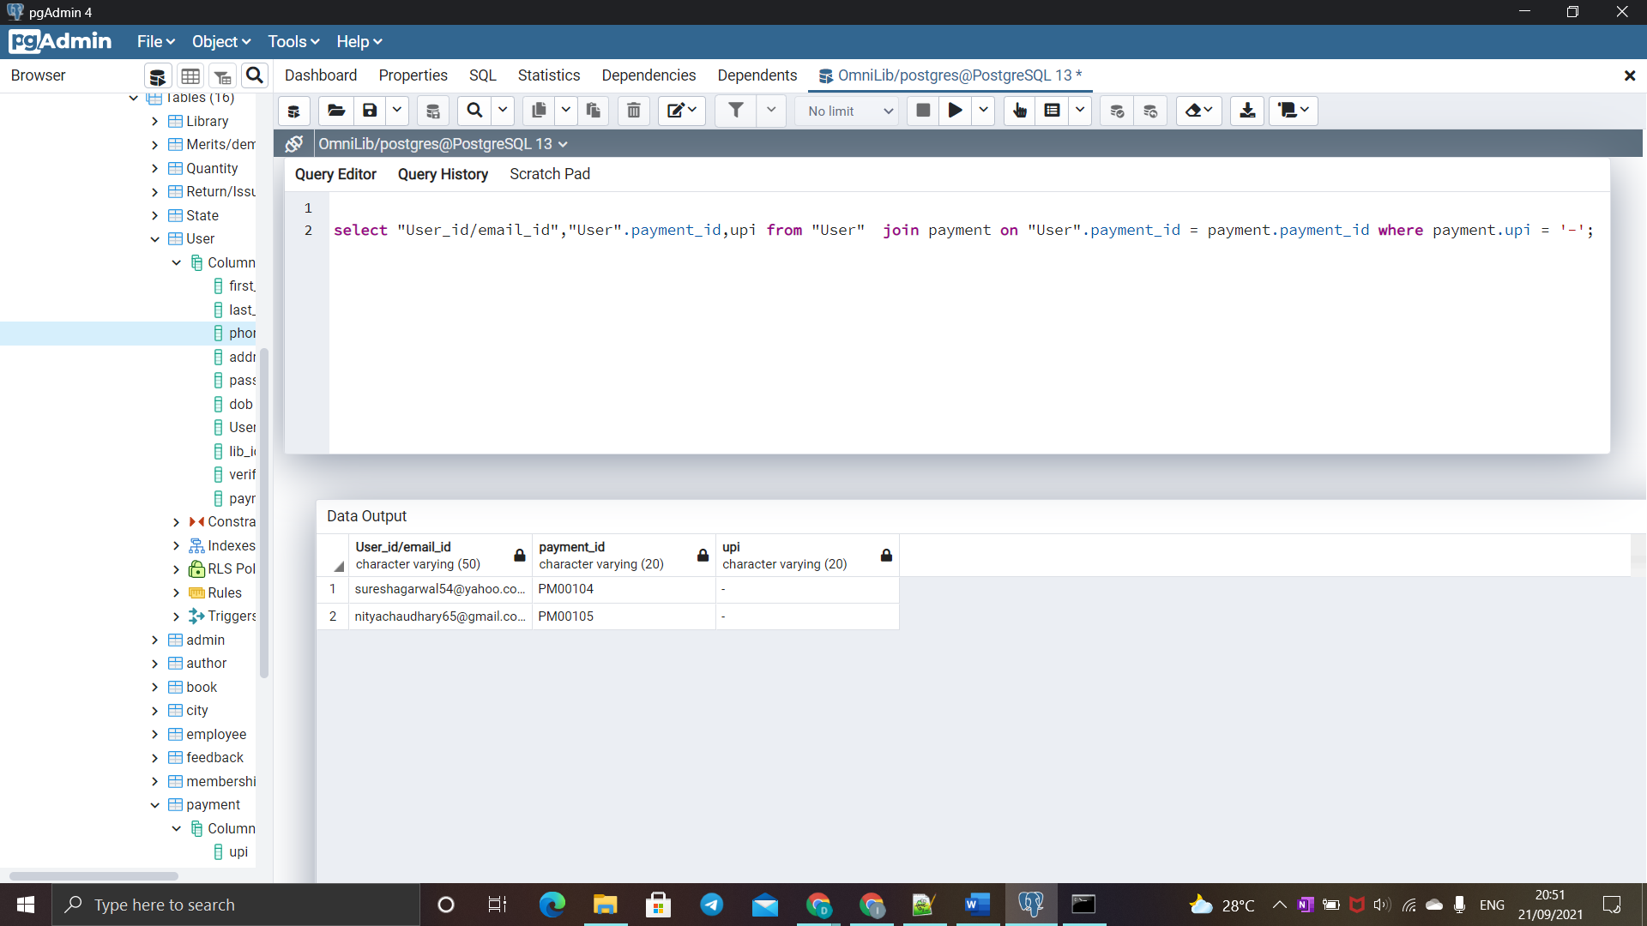

**Left Join**

**2) select first_name,last_name,"User".lib_id,"User"."User_id/email_id",**

**u_name,review,rating**

**from "User" left join feedback on**

**"User"."User_id/email_id" = feedback."User_id/email_id";**

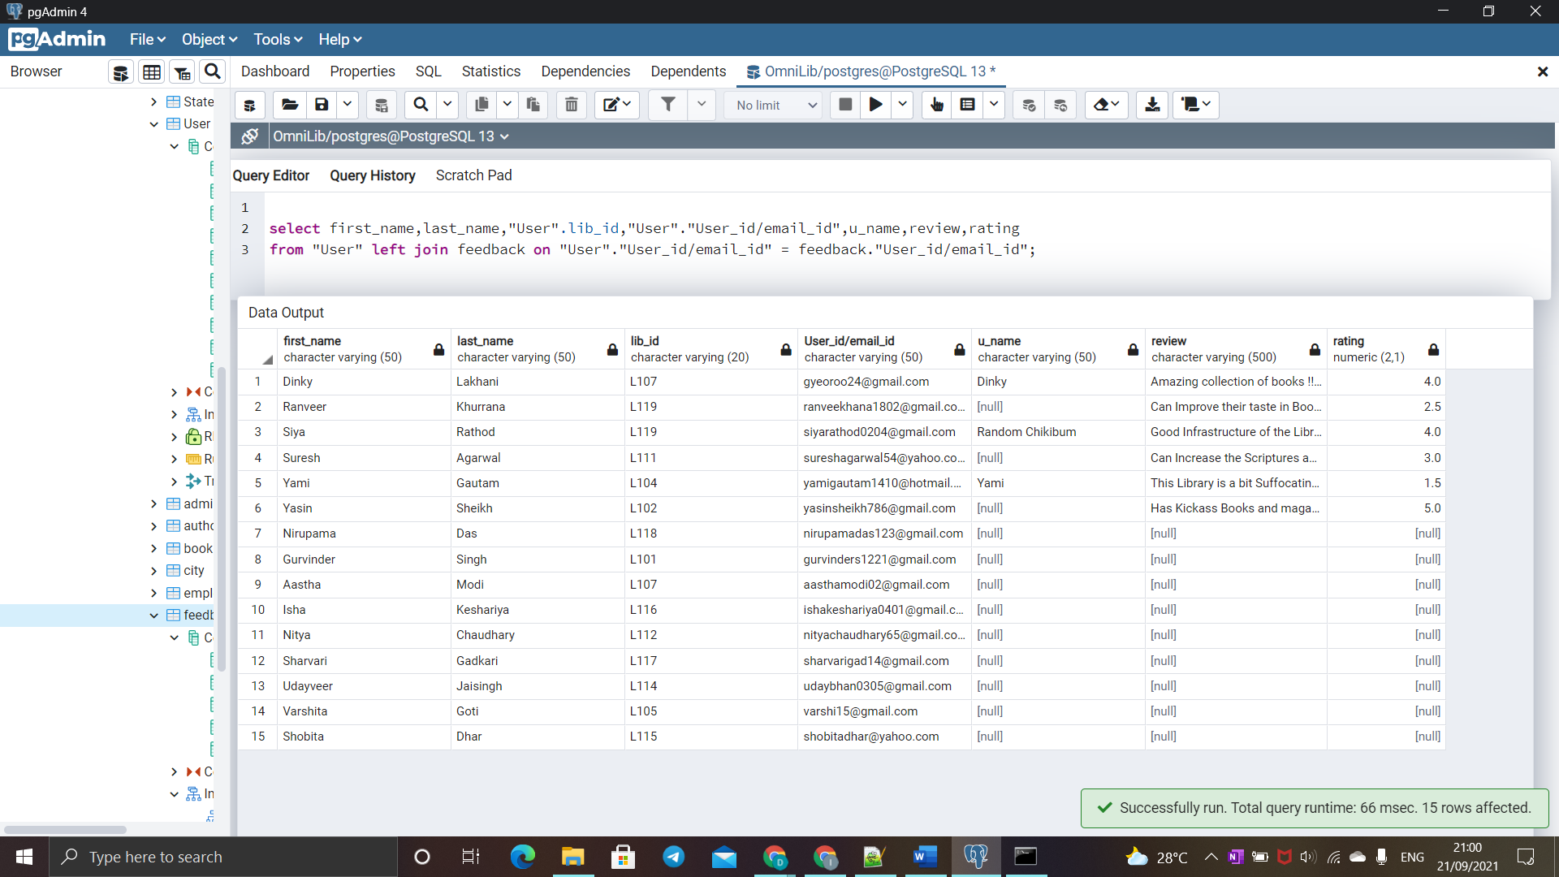

**Right Join**

**3) select first_name,last_name,"admin".lib_id,"admin"."User_id/email_id",rating,**

**"Merits/demerits"."User_id/email_id"**

**from "Merits/demerits" right join "admin"**

**on "admin"."User_id/email_id" = "Merits/demerits"."Admin_User_id/email_id";**

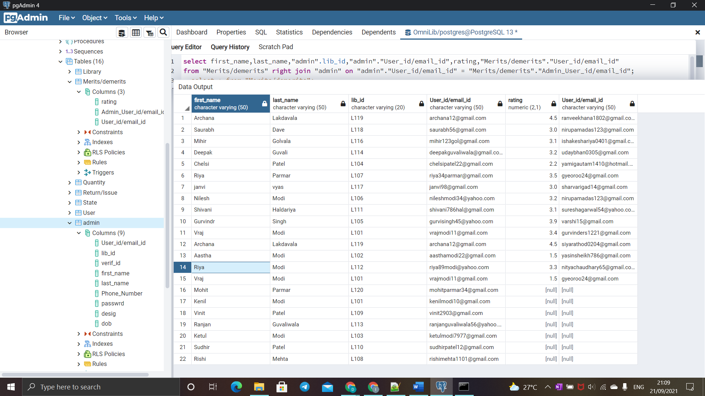

**Full join**

**4) select first_name,last_name,"Library".lib_id,dob,lib_name from**

**"Library" full join "User" on "Library".lib_id = "User".lib_id;**

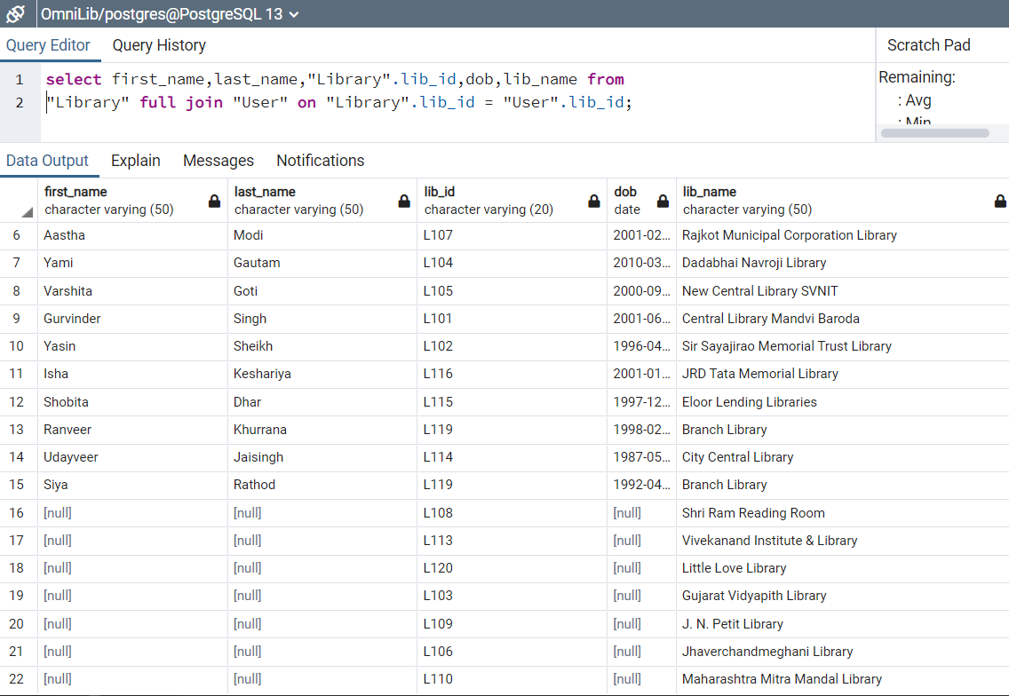

**Self Join**

**Authors having certain ISBN**

**5) select distinct author1.author_name a_name,author1.author_id aid ,author1.isbn a1_isbn**

**from author author1 inner join author author2 on author1.isbn = author2.isbn**

**and**

**author1.isbn in (9780143130727,9780241370148);**

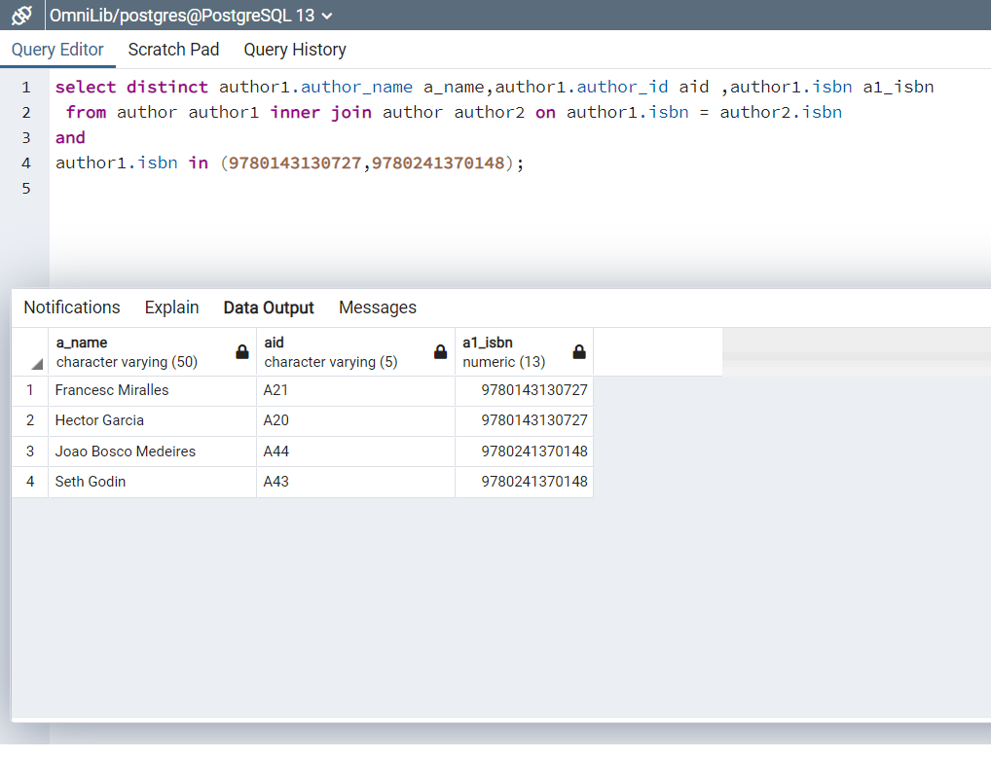

**Books having multiple authors**

**6) select t1.author_name,t1.isbn from author t1 , author t2**

**where t1.isbn = t2.isbn AND t1.author_id<> t2.author_id;**

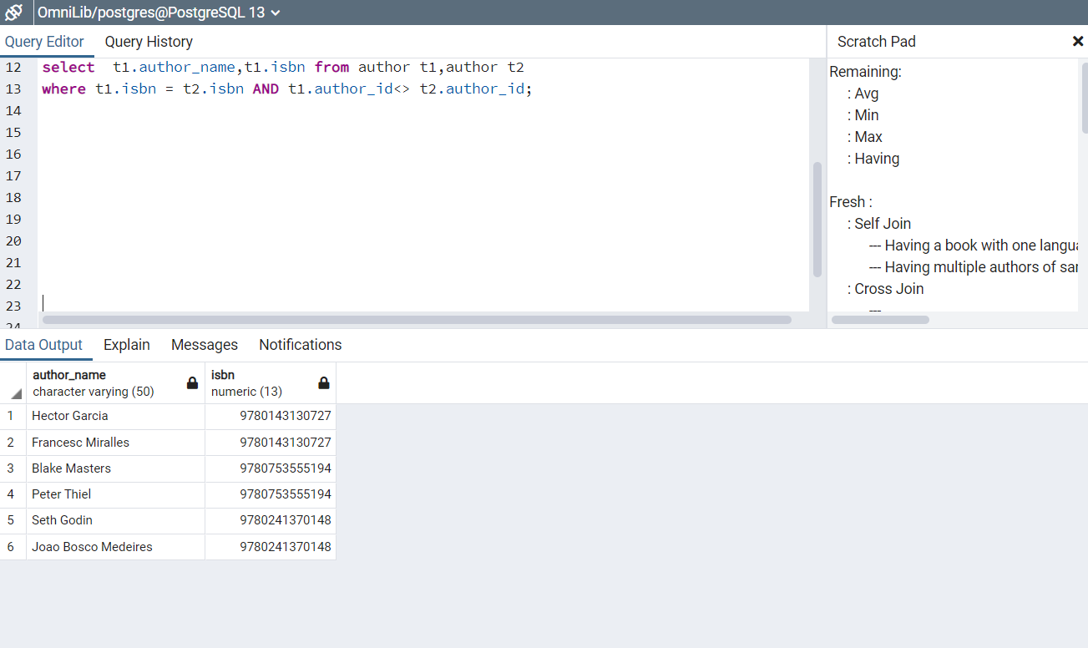

**Sub queries**

**Correlated**

**Books having multiple authors**

**7) select author.author_name aname,author.author_id aid,author.isbn isbn_a**

**from author where isbn in**

**(select isbn from author group by isbn having count(author_name) > 1);**

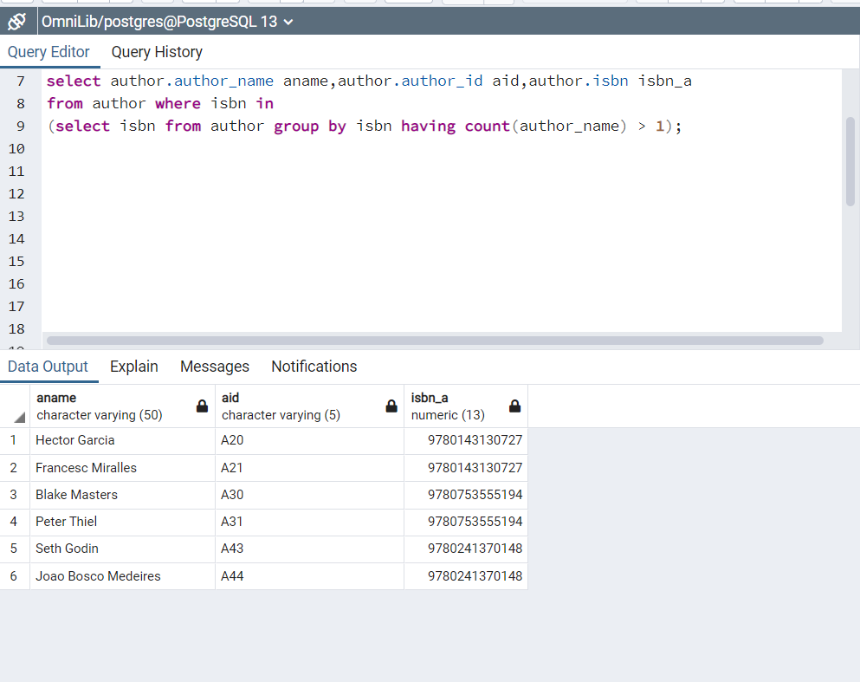

**Employees of library having Second Maximum Salary**

**8) select first_name,last_name,salary from**

**employee where salary=**

**(select max(salary) from employee**

**where salary<> (select max(salary) from employee));**

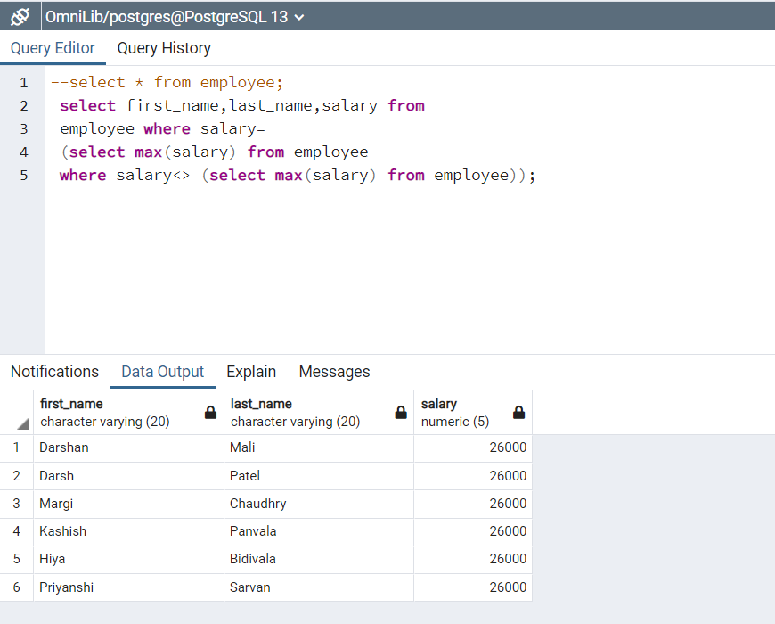

**Average fund of cities**

**9) select city.city_name,avg(funds) from "Library"**

**full join city on "Library".city_id = city.city_id group by(city.city_name) order by city_name asc;**

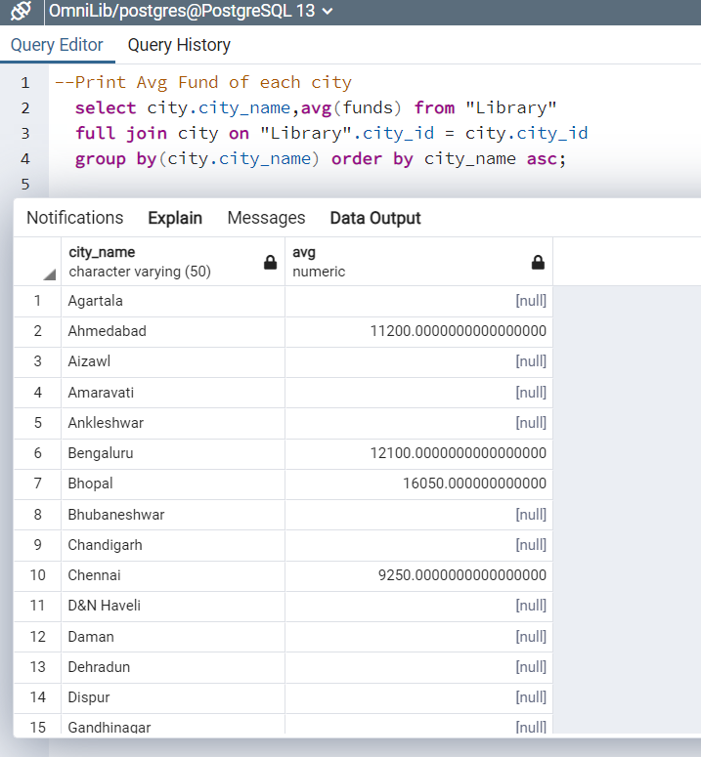

**Select * from “Library”;**

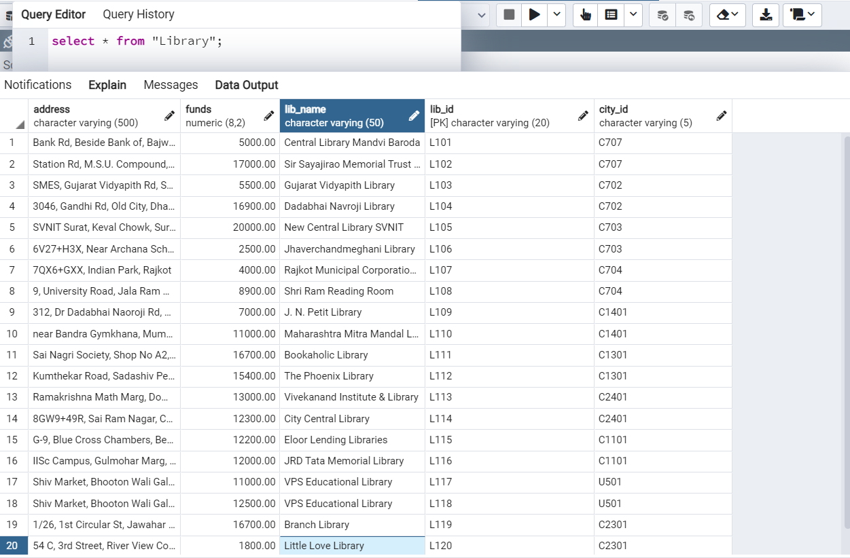

**Independent**

**Library having minimum fund**

**10) select lib_id,lib_name ,funds from "Library"**

**where funds = (select min(funds) from "Library");**

